**Contents**

The Battle of the Neighborhoods 2

1 Introduction & Business Problem : 2

2

2 Target Audience: 2

3 Success Criteria: 2

4 Data : 2

5 Methodology: 3

6 Results 4

7 Conclusion 6

8 Discussion 6

**Figure Index**

Figure 1: Map of restaurants in Santiago, Chile 4

Figure 2: Geo Locations from “Metropolitana de Santiago” sushi restaurant(show the first 5

Figure 3: Sushi restaurant locations 5

Figure 4: Final result corresponding to the score 6

Figure 5: Suitable location to place a restaurant 7

Figure 6: Discussion 8

# The Battle of the Neighbourhoods

# Introduction & Business Problem :

The main topic is to put on work a sushi restaurant that will be located in Santiago, Chile. This project contemplate the investigate where is the best location to install a shop like that

**Business problem:**

located the restaurant in a place where the target audience could easily go and in the possible be the only sushi local in the area.

# Target Audience:

To open a sushi restaurant, we'll use the Foursquare information on the communes or localities of Santiago (Chile). For this we define our target audience:

* Schools
* Universities
* Offices

This scope is defined to have the highest public captation and the proximity of other stores offering the same or similar products will be taken into account

# Success Criteria:

The success criteria of the project will be a good recommendation of borough/Neighbourhood choice based on the differentiation of such restaurants in that location and nearest suppliers of ingredients.

# Data :

To find the best location for our sushi place, we will use the following sources of information:

From Wikipedia (tables):

* Locations: <https://es.wikipedia.org/wiki/Anexo:Comunas_de_Chile_por_poblaci%C3%B3n>
* PostCodes- <https://es.wikipedia.org/wiki/Anexo:C%C3%B3digos_postales_de_Chile>

From Files:

Geo Location: <https://raw.githubusercontent.com/ssikam/My-Capstone-Project/master/chile%20geo%20public.csv>

From Foursquare:

Venues Categories: <https://developer.foursquare.com/docs/resources/categories>

* Sushi - 4bf58dd8d48988d1d2941735
* Highschool - 4bf58dd8d48988d13d941735
* University - 4bf58dd8d48988d1ae941735
* Office - 4d4b7105d754a06375d81259

# Methodology:

He collected different sources of information such as locations, zip codes, geographic locations to import all this data into a Jupyter notebook.

The selection was based solely on the place of the restaurant or locations in Santiago, Chile, to filter the results that we use the "Metropolitan of Santiago" leaving a total of 52 locations, joined all bases, leaving a size of (52.4).

Information about sushi restaurants, schools, universities and offices was sought for each location obtain this information from Foursquare.

For each location we group and count each of the 4 categories, defined a weight for each category, depending on the recurrence you may have in our sushi restaurant, like:

* Sushi restaurant: -1 points (the more restaurants there are in a sector, the less important it’s to us)
* Schools: 1 point (they are good clients, but it depends on the money their parents give them)
* Universities: 2 points (they are good clients and with more economic independence than the students)
* Offices: 3 points (they have their own income and could be frequent clients)

For each location we calculate a final score and order the resulting data from highest to lowest. The place with the highest score will be where we will put our sushi bar.

# Results

The image show us the map of Santiago, Chile

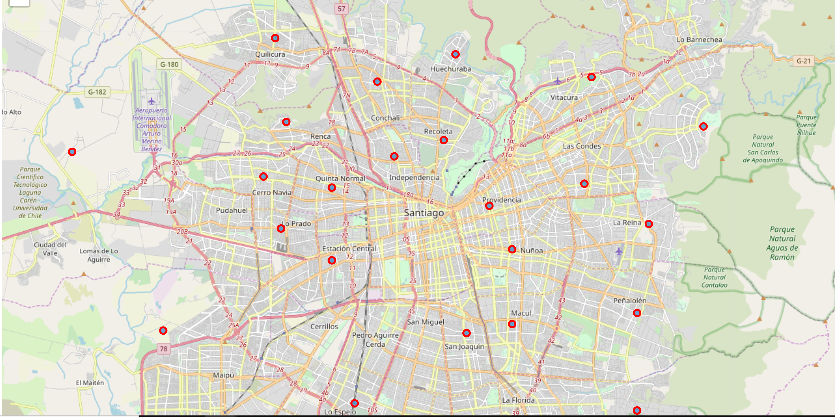

Figure 1: Map of restaurants in Santiago, Chile

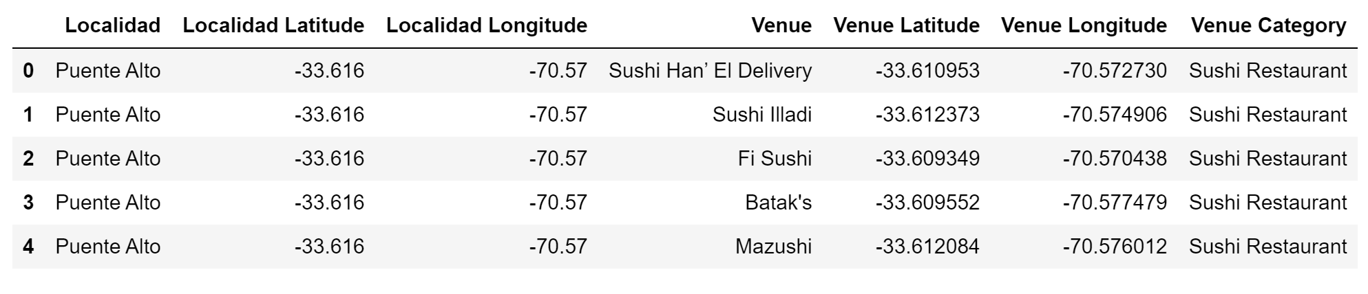

Figure 2: Geo Locations from “Metropolitana de Santiago” sushi restaurant(show the first 5)

In the map of restaurant we can see that Santiago have 184 Sushi Restaurants indicated with the dark blue dot.

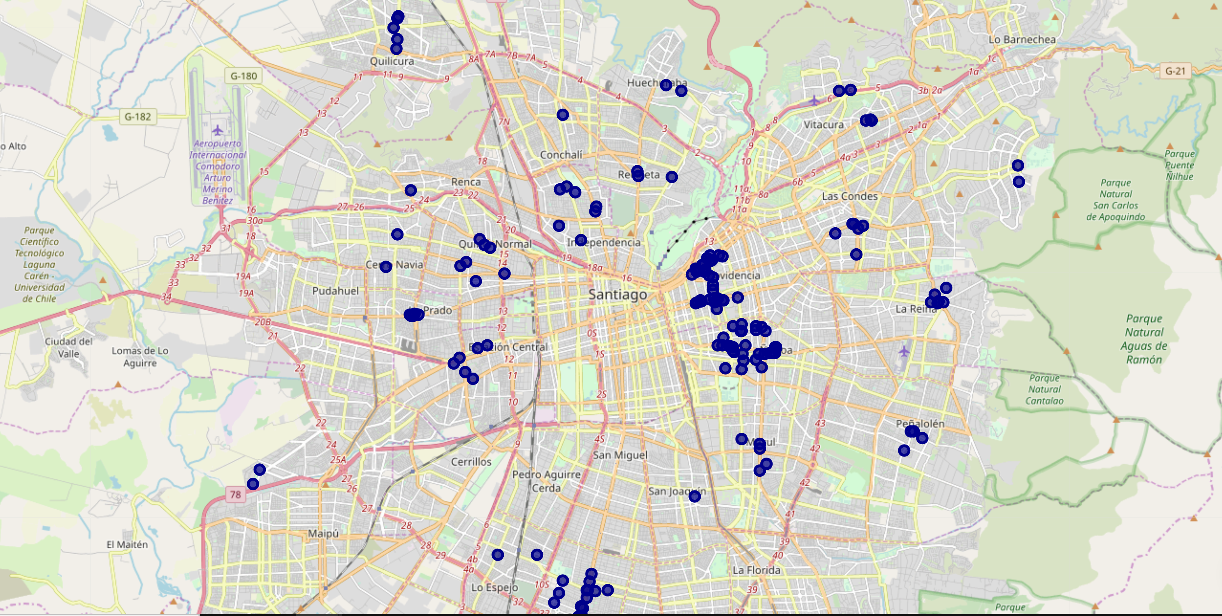Figure 3: Sushi restaurant locations

So with the score given in the methodology, it calculated a score table to see where is the best place to install a restaurant.

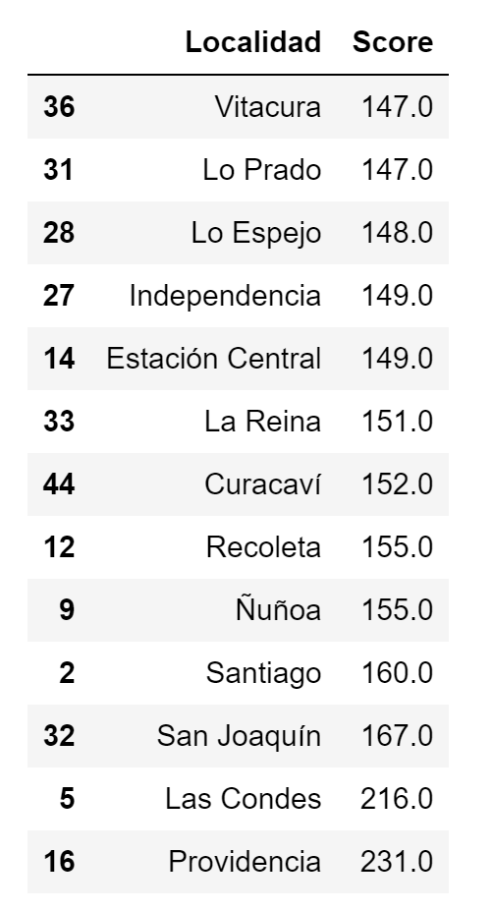

Figure 4: Final result corresponding to the score

# Conclusion

In the image we can see that the suitable place to install a sushi restaurant is indicated with a blue dot, The locality with best score is “Providencia” with 231 pts.

The red dots are the other sushi restaurant, the yellow represent the universities, high school with the green and the office with the fuchsia dot.

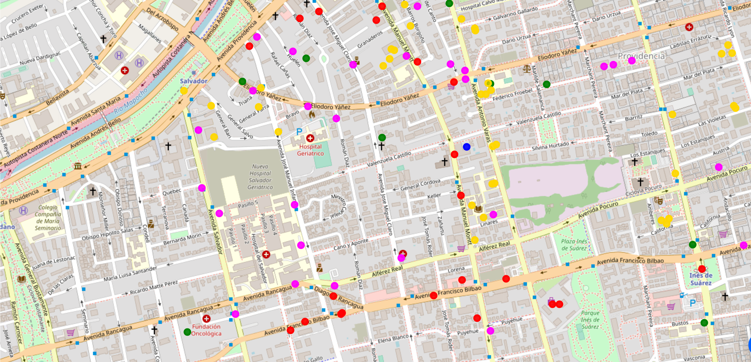Figure 5: Suitable location to place a restaurant

With this result we maximize the number of potential customers who will visit our sushi restaurant.

# Discussion

As we can discuss, how about we allocated the restaurant in the orange circle?, there are more office and universities as well as high schools, 3 of the target market, we can captive more clients, how about in the nights?.

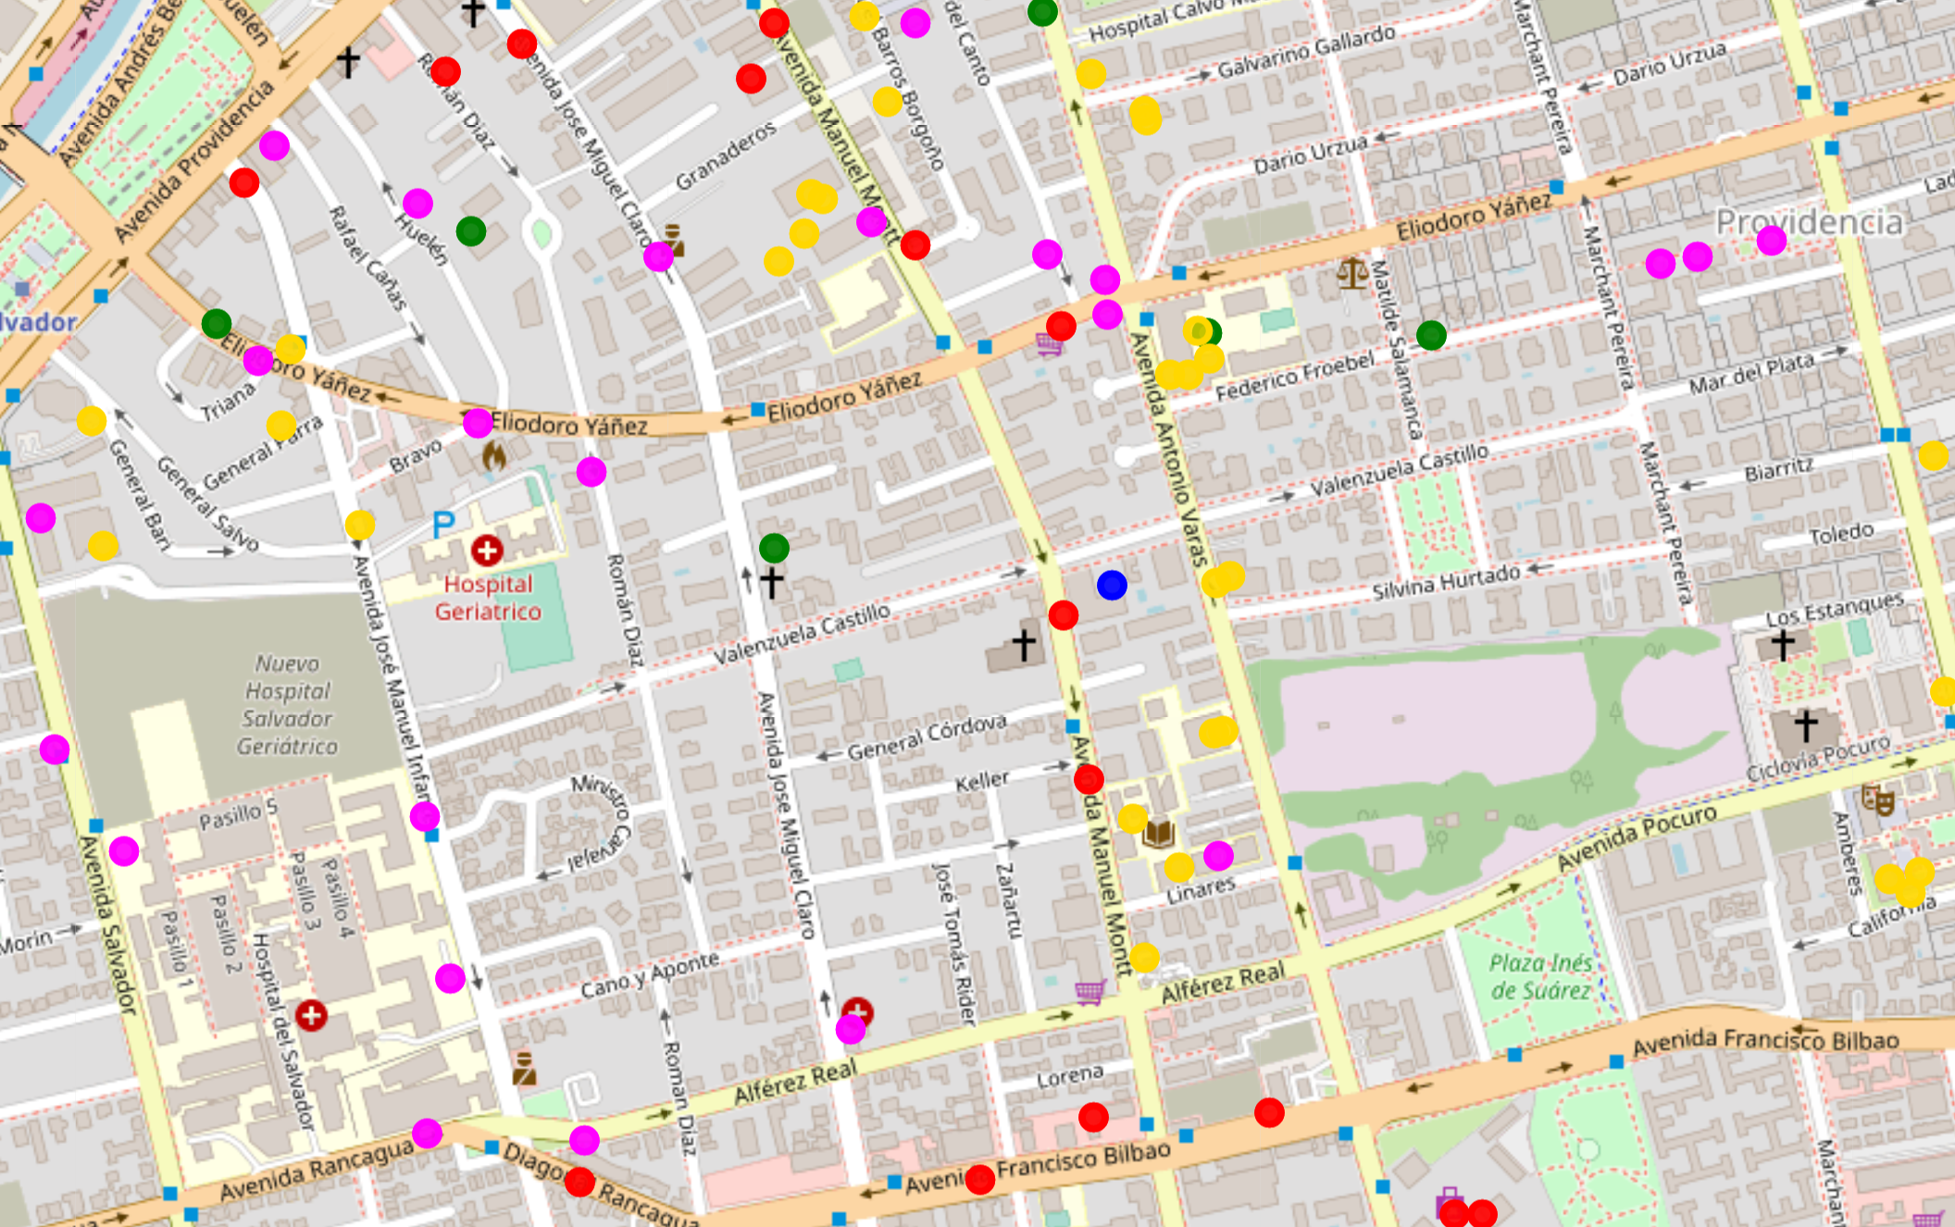

Figure 6: Discussion